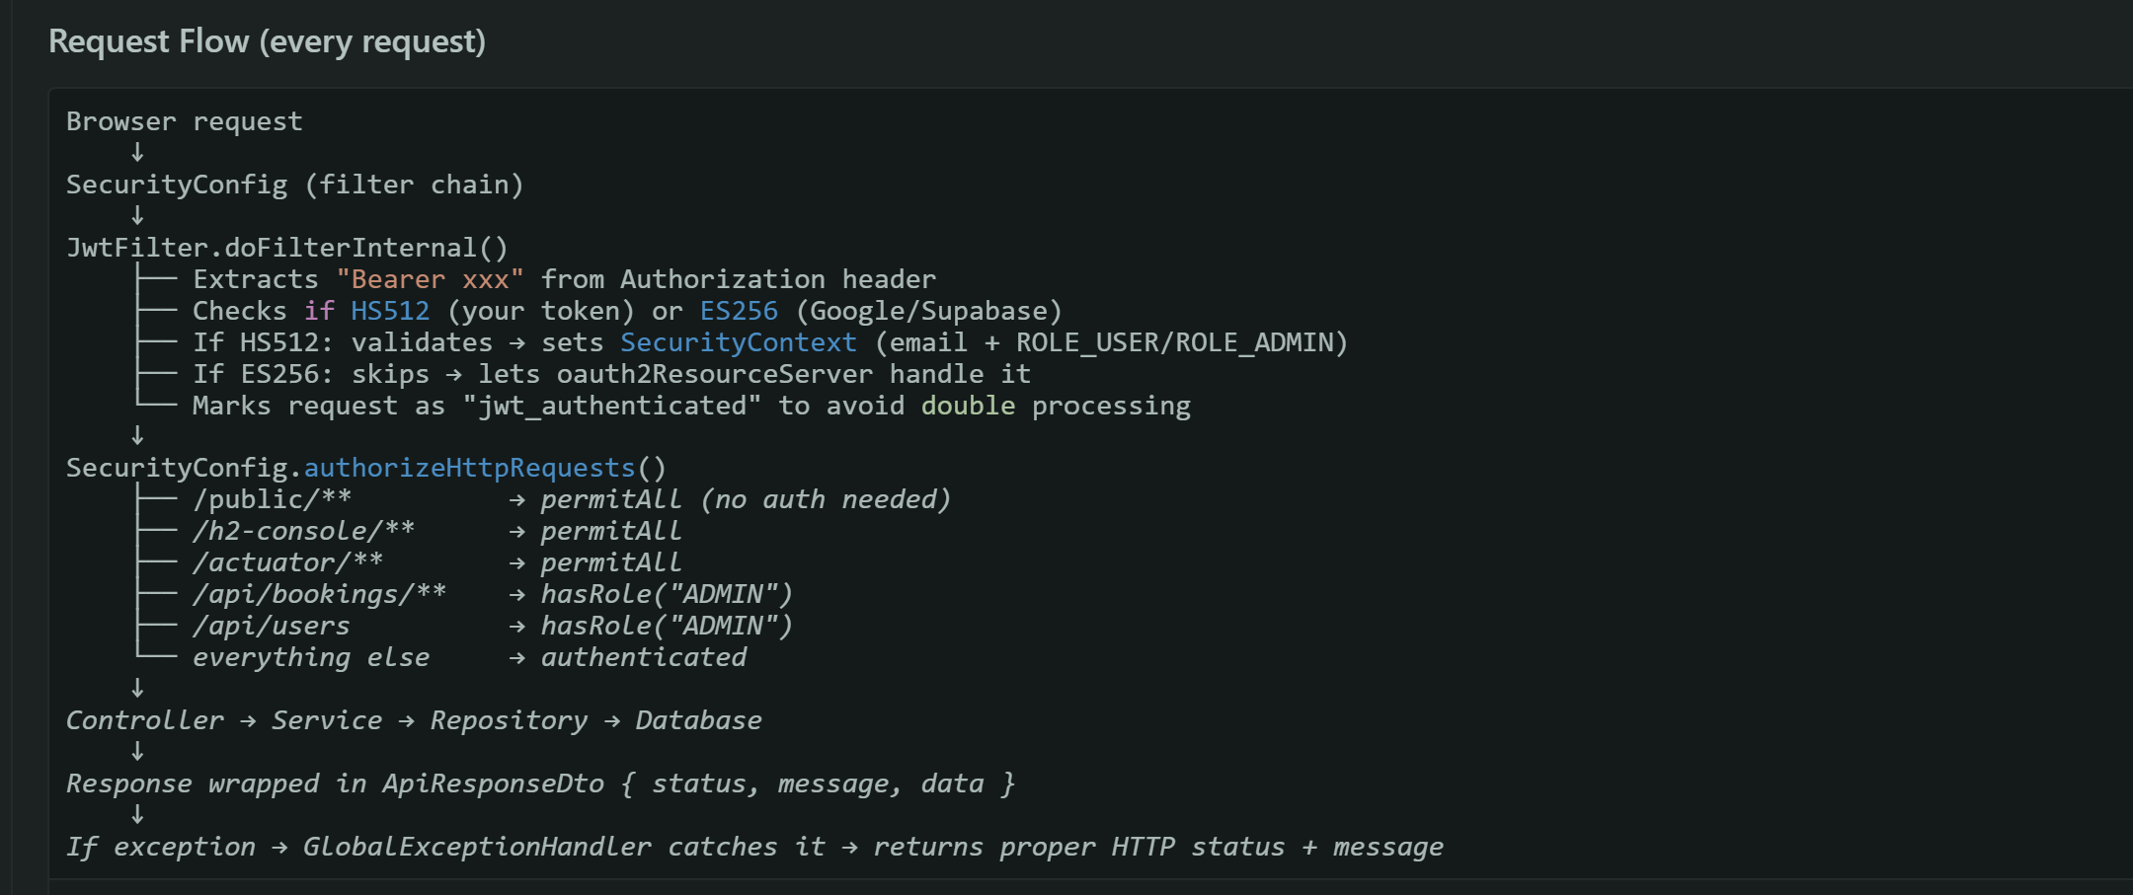

In Java persistence frameworks like JPA (Java Persistence API) or Hibernate, the @ManyToOne annotation is used to define a many-to-one relationship between two entities. This means that many instances of the entity containing the annotation can be associated with a single instance of another entity.
Example
@Entity
public class Order {
@Id
private Long id;

@ManyToOne(fetch = FetchType.LAZY) // default is EAGER in some implementations
@JoinColumn(name = "customer_id")
private Customer customer;
}
In this example, multiple Order entities can be tied to a single Customer entity.
Relation to N+1 Queries
Problem: N+1 Query
- If @ManyToOne is configured with FetchType.LAZY (recommended for performance), Hibernate will not load the associated Customer initially when retrieving Order entities.
- However, if code accesses order.getCustomer() in a loop, for 100 orders, Hibernate will execute 1 query for orders + 100 queries for customers, which is the classic N+1 problem.
Solution Approaches
- Eager Fetching Carefully (FetchType.EAGER):
- @ManyToOne(fetch = FetchType.EAGER)
  - Automatically fetches associated entities in the same query.
  - Risk: may load too many unnecessary records if not careful.
- Join Fetch Queries (Recommended):
- List<Order> orders = entityManager
- .createQuery("SELECT o FROM Order o JOIN FETCH o.customer", Order.class)
- .getResultList();
  - Reduces N+1 problem by retrieving all data in a single query with a join.
- Batch Fetching (Hibernate-Specific):
- @BatchSize(size = 10)
- @ManyToOne(fetch = FetchType.LAZY)
- private Customer customer;
  - Fetches associated entities in batches to mitigate excessive queries.
Relation to Stale Data
- Stale data occurs when cached entity states are outdated.
- @ManyToOne itself does not directly prevent stale data. However:
  - Using lazy loading with proper session and transaction management ensures the entity's state is fetched only when necessary.
  - Using refresh or optimistic locking can help maintain consistency to avoid stale data when updating associated entities.
Key Takeaways
- @ManyToOne defines a many-to-one relationship; fetching strategy significantly impacts performance.
- To fix N+1 queries:
  - Prefer join fetch or batch fetching over default lazy loading in loops.
- To avoid stale data:
  - Ensure proper transaction/session scope.
  - Consider caching strategies and refresh mechanisms.

Best Practices and Key Takeaways
- Always consider fetch strategy:
  - Lazy loading is safer for performance; combine with join fetch when querying collections.
  - Batch or Eager fetching can supplement in read-heavy scenarios.
- Avoid N+1 queries by planning JPQL/HQL queries effectively.
- Maintain data consistency with proper session management, caching, and optimistic/pessimistic locking.
- Use @ManyToOne in combination with @JoinColumn to clearly define foreign key relationships.

@ManyToOne allows you to:
- Model relationships naturally between entities.
- Enhance performance by controlling fetching behavior.
- Mitigate excessive queries and handle stale data issues effectively.
- Understand and solve ORM-specific problems that affect large-scale applications.
In essence, @ManyToOne is simple but powerful, and mastering its proper use is crucial to writing efficient, reliable Java persistence code.
Rate Limiting — Two Options
Option A: Simple filter (no library needed)
Create a filter that tracks requests per IP using an in-memory map:
@Component
public class RateLimitFilter extends OncePerRequestFilter {

// IP → list of request timestamps
private final Map<String, List<Long>> requests = new ConcurrentHashMap<>();
private static final int MAX_REQUESTS = 5;
private static final long WINDOW_MS = 60_000; // 1 minute

@Override
protected void doFilterInternal(HttpServletRequest request,
HttpServletResponse response,
FilterChain chain) throws ServletException, IOException {
String ip = request.getRemoteAddr();
long now = System.currentTimeMillis();

requests.computeIfAbsent(ip, k -> new ArrayList<>())
.removeIf(t -> now - t > WINDOW_MS);

if (requests.get(ip).size() >= MAX_REQUESTS) {
response.setStatus(429);
response.getWriter().write("{\"status\":429,\"message\":\"Too many requests\"}");
return;
}

requests.get(ip).add(now);
chain.doFilter(request, response);
}

@Override
protected boolean shouldNotFilter(HttpServletRequest request) {
String path = request.getRequestURI();
// Only rate limit auth endpoints
return !path.startsWith("/public/api/auth/");
}
}
Copyjava
Then register it in SecurityConfig before JwtFilter.
Option B: Resilience4j (production-grade)
Add dependency:
<dependency>
<groupId>io.github.resilience4j</groupId>
<artifactId>resilience4j-spring-boot3</artifactId>
<version>2.3.0</version>
</dependency>
Copyxml
Config in
application.yaml
:
resilience4j:
ratelimiter:
instances:
authLimit:
limit-for-period: 5
limit-refresh-period: 60s
timeout-duration: 0s
Copyyaml
Then on controller:
@PostMapping("/login")
@RateLimiter(name = "authLimit")
public ResponseEntity<ApiResponseDto<LoginResponseDto>> login(...) {
Copyjava
My recommendation: Start with Option A — zero dependencies, works fine for your scale. Move to Resilience4j when you need per-user limits or distributed rate limiting.

Async Email — Simple Fix
Step 1: Add
@EnableAsync
to your main class:
@SpringBootApplication
@EnableAsync
public class GlobalPassApplication {
Step 2: Add
@Async
to the email method:
@Async
public void sendPasswordResetEmail(String toEmail, String resetToken) {
// same code — now runs in a separate thread
// user gets instant response, email sends in background
}
That's it. The request returns immediately, email sends in a background thread.
Optional improvement — custom thread pool so email sending doesn't steal threads from request handling:
@Configuration
@EnableAsync
public class AsyncConfig {

@Bean("emailExecutor")
public Executor emailExecutor() {
ThreadPoolTaskExecutor executor = new ThreadPoolTaskExecutor();
executor.setCorePoolSize(2);
executor.setMaxPoolSize(5);
executor.setQueueCapacity(50);
executor.setThreadNamePrefix("email-");
executor.initialize();
return executor;
}
}
Then:
@Async("emailExecutor")
public void sendPasswordResetEmail(...) {
Summary:
- Rate limiting → simple filter on
/public/api/auth/*
, 5 requests per minute per IP
- Async email →
@EnableAsync
+
@Async
on EmailService method

The decision tree:
- Do you have multiple backend instances? → No → skip queue
- If email fails, must it retry automatically? → Not critical for password reset → skip queue
- Do other services need to know "email was sent"? → No → skip event-driven

When you'd upgrade:
- @Async → Queue (SQS/RabbitMQ) when: you deploy multiple servers (the in-memory thread pool is per-instance, so retries are lost if server restarts)
- Queue → Event-driven (Kafka/SNS) when: you add notifications like "send email + send SMS + update analytics" all from one event
For GlobalPass right now: @Async
handles it. You're sending maybe a few password reset emails per day. A message queue adds infrastructure complexity (broker setup, dead letter queues, monitoring) for zero benefit at this stage.

/v1
/v2
For your project right now: It doesn't matter. You have one frontend, one backend, you deploy both together. Versioning matters when you have multiple clients (mobile app, third-party integrations, public API) that update at different times.

If you’re still building apps like the one shown → focus on:
- Relational database design (normalization, joins)
- JPA/Hibernate behavior (lazy vs eager, N+1, cascading)
- Clean architecture inside a monolith
- Transaction boundaries
The image is basically telling you:
- What you're doing is correct for a monolith
- Some “microservices best practices” would actually be wrong in your current setup
In your current monolith
These are all good choices:
- @ManyToOne relationships → fine (single DB, ORM handles joins)
- JOIN FETCH → good (avoids N+1 queries)
- No denormalization → correct (you can join anytime)
- ON DELETE CASCADE → safe (DB enforces consistency)
- Direct repository access → simple and efficient
👉 Everything works because:
You have one database and one transactional boundary

🔄 In microservices architecture
These are the correct choices:
- No @ManyToOne across services → use IDs only (no shared ORM relationships)
- No JOIN FETCH → fetch data via API calls or aggregation layer
- Denormalization → required (store things like userName, bookingName)
- No ON DELETE CASCADE → use events for cleanup (async handling)
- No direct repository access → communicate via service APIs
👉 Everything works because:
You have separate databases per service and no shared transactions
🧠 One-line difference
- Monolith: “I can join everything”
- Microservices: “I must coordinate everything”

Next task Why:-
1 Rate limiting on /public/api/auth/* Brute force protection
2 @Transactional across booking + payment (handle orphan bookings) Data integrity
3 @Async email sending Don't block user on password reset
4 Fix BookingMapper warnings (add @Mapping(target = "id", ignore = true) etc.) Clean compile.
Day 2 — Critical fixes
- Rate limiting on
/public/api/auth/*
— prevent brute force login/signup
- Orphan booking fix — if payment upload fails, delete the booking (or combine into one backend endpoint)
- @Async
email sending — password reset email doesn't block the request thread
- IllegalStateException
handler — duplicate payment and cancel-verified errors return proper 409/400 instead of 500
- AccessDeniedException
handler — permission denied errors return
ApiResponseDto
format instead of Spring's default
Day 3 — Performance + data
- Pagination on list endpoints — all "get all" endpoints return pages instead of entire table
- @Cacheable
on frequently read data — user profile, booking list cached to reduce DB hits
- Database migrations (Flyway) — track every schema change in version-controlled SQL files, safe deployments
- Soft delete — deleted records get
deleted_at
timestamp instead of being removed permanently, allows recovery
- Audit trail — separate table logging who did what and when (admin approved payment X at time Y)
Day 5 — Testing + observability
- Unit tests (services) — test AuthService, BookingService, PaymentService, UserService logic in isolation
- Unit tests (security) — test JwtFilter, SecurityUtil, JwtUtil
token generation/validation
- Integration tests — full flow: signup → login → create booking → upload payment → admin approves
- Structured logging (JSON format) — logs are machine-parseable, searchable in production monitoring tools
- Request tracing (correlation ID) — every request gets a unique ID that follows it through all layers, makes debugging production issues possible

1, Rate limiting: -
Why rate limiting is important
1) Prevent attacks
Stops:
- DDoS attacks
- Brute force login attempts
- Bots scraping data
2) Protect server resources
Every request uses:
- CPU
- Memory
- Database
👉 Without limits → server crashes
3) Fair usage
Prevents one user from: -Taking all the system capacity
⚠️ Common mistake
- Too strict limits → users frustrated
- Too loose limits → system crashes
👉 Best algorithm:
- Sliding window (accurate)
- Token bucket (flexible)

DDoS attacks, where multiple systems flood the bandwidth or resources of a targeted system, can be devastating.
brute force attacks, which attempt to gain unauthorized access by systematically checking all possible passwords, pose a significant threat.
Rate limiting acts as a first line of defense, limiting the effectiveness of such attacks by restricting the number of requests an attacker can make.
Rate limiting restricts the number of API requests a client can make during a defined period. If a client exceeds the threshold, additional requests receive an HTTP 429 error (Too Many Requests) until the time window resets.
Rate limiting operates at different infrastructure layers:-
- Edge-level limiting at CDNs stops malicious traffic before reaching servers
- Application-level limiting provides granular control based on business logic
- Gateway-level limiting enforces policies across all API traffic
How to Test API Rate Limiting: -
Testing validates that your rate limiting stops attacks without blocking legitimate traffic.
- Send requests exceeding configured limits and verify HTTP 429 responses
- Test from multiple IP addresses to confirm per-client limits work
- Verify limits reset after the configured time window
- Validate error responses include Retry-After and X-RateLimit headers
Distributed Rate Limiting: -
- For services that scale horizontally, ensuring consistent rate limiting across multiple instances is a challenge. Distributed rate limiting solutions, which share state across servers or rely on centralized data stores like Redis, can help maintain accurate rate limiting in distributed architectures.

What is API Rate Limiting? Understanding Best Practices
Fintech API Security Checklist: Avoid Disaster | APIsec
Top API Security Testing Tools You Need Now | APIsec
SQL Injection in APIs: Testing, Exploitation, and Prevention | APIsec
Summary: -
For your app today (MVP):
- In-memory token bucket using Bucket4j
- Per-IP limit on auth endpoints (login, signup, forgot-password)
- No Redis, no external dependencies
- Simple servlet filter
When you grow (Phase 2):
- Same Bucket4j but backed by Redis
- Per-user limits (not just per-IP)
- Works across multiple server instances
At scale (Phase 3):
- API Gateway (Kong/Spring Cloud Gateway) handles rate limiting
- Multi-layer: global → per-user → per-endpoint → risk-based
- Distributed Redis cluster
- Plus WAF, fraud detection, geo-blocking

Algorithm choices:
- Token Bucket = allows bursts, most practical (use this)
- Sliding Window = most accurate, stricter (use for critical endpoints like login)
Your implementation today: Bucket4j + in-memory + filter on
/public/api/auth/*— 5 login attempts per minute per IP.

1, How to implement rate limiting
What we're building:
A filter that counts login/signup attempts per IP address. If someone tries more than 5 times in 1 minute, they get blocked with 429 (Too Many Requests).

Why:
Without this, an attacker can try thousands of passwords per second against your login endpoint until they guess one. This is called brute force. Rate limiting stops it.
How it works:
Request comes in → Filter checks IP
↓
Has this IP made 5+ requests in the last minute?
├── No → Allow request through → Controller handles it
└── Yes → Block immediately → Return 429 "Too many requests"
Implementation approach:-

We'll use Bucket4j (token bucket library). Each IP gets a "bucket" with 5 tokens. Each request consumes 1 token. Tokens refill at 5 per minute. Empty bucket = blocked.
Here’s the difference:

Per-IP limits: -
Limits are applied to the network address.
Everyone sharing the same IP counts together.
Example: a school, office, or café Wi-Fi could hit the limit because many people share one IP.
Per-user limits
Limits are applied to each logged-in user or API key separately.
Different users on the same network each get their own allowance.
Example: 50 people in one office can each have independent quotas.
Why this matters: -
Per-user is usually fairer and harder to abuse.
Per-IP is simpler but can block innocent users sharing a network.
Many services use a mix of both:
per-user for normal quotas,
per-IP for anti-spam or security protection.

IP: -
A web app can use several different IPs for rate limiting, depending on how it’s built.
Most commonly it uses the public client IP — the IP address visible to the server on the internet.

Typical setup: -
Your device has a private IP
Example: 192.168.1.5
Your router changes it to one public IP using NAT
Example: 81.x.x.x
The website sees only the public IP
So rate limiting is usually applied to 81.x.x.x
But modern apps often combine multiple things:
IP address
User account / login
Session cookie
API key
Device fingerprint
User-Agent header

What is @Transactional in Spring Boot?
@Transactional is a Spring annotation that ensures a method runs inside a database transaction—meaning either:
- ✅ everything succeeds → changes are saved (COMMIT)
- ❌ something fails → everything is rolled back (ROLLBACK)

🧠 Why do we need it?
Without @Transactional, your DB operations are not atomic.
❌ Problem without transaction:
Step 1: Save user ✔
Step 2: Deduct wallet ❌ (fails)
→ Now user exists but money not deducted → inconsistent state

✅ With @Transactional:
Step 1: Save user ✔
Step 2: Deduct wallet ❌
→ EVERYTHING is rolled back → like nothing happened
👉 This ensures data consistency

⚙️ How it works internally
Spring uses:
- A proxy around your method
- A database transaction manager
- JDBC / JPA transaction APIs
Flow:
Start Transaction
↓
Execute method
↓
Success → COMMIT
Error → ROLLBACK

🛠️ Basic usage
1. On service method (MOST COMMON)
@Service
public class UserService {
@Transactional
public void createUser() {
userRepository.save(new User());
walletRepository.save(new Wallet());
}
}

🔥 Real Use Cases
🏦 1. Banking / Fintech (MOST IMPORTANT)
@Transactional
public void transferMoney() {
debitAccount(); // subtract money
creditAccount(); // add money
}
👉 If any step fails → rollback everything

🧾 2. Order & Payment system
@Transactional
public void placeOrder() {
createOrder();
reduceInventory();
processPayment();
}
👉 Prevents:
- order without payment
- payment without order
- inventory mismatch

👤 3. User creation with multiple tables
@Transactional
public void registerUser() {
saveUser();
saveProfile();
assignRoles();
}

📦 4. Inventory management
@Transactional
public void updateStock() {
decreaseStock();
logStockHistory();
}

⚠️ Important Rules (VERY IMPORTANT)
❗ 1. Only works on Spring-managed beans
- Must be inside @Service, @Component, etc.

❗ 2. Self-invocation does NOT work
public void methodA() {
methodB(); // ❌ @Transactional on methodB won't work
}

❗ 3. Only Runtime exceptions trigger rollback by default
throw new RuntimeException(); // ✅ rollback
throw new Exception(); // ❌ NOT rollback by default
Fix:
@Transactional(rollbackFor = Exception.class)
⚙️ Advanced options
🔹 rollbackFor
@Transactional(rollbackFor = Exception.class)
🔹 isolation level
Controls concurrency behavior:
@Transactional(isolation = Isolation.READ_COMMITTED)
Best Practice
👉 Put @Transactional on service layer, not controller
Controller → Service (@Transactional) → Repository

🔥 Final Summary
- @Transactional = ensures data consistency
- It wraps method in a DB transaction
- Success → commit, failure → rollback
- Essential for finance, orders, inventory systems
- Always use at service layer

@Async Email Sending in Spring Boot (Password Reset Use Case)
🟢 Simple & Clear
- Asynchronous Email Sending in Spring Boot using @Async (Password Reset Flow)
🟡 Interview-Focused
- Scalable Email Processing in Spring Boot: From @Async to Enterprise Architecture
🔵 Architecture-Focused
- Designing Non-Blocking Email Systems in Spring Boot: MVP to Enterprise Scaling

🎯 Problem (Without @Async)
When a user requests a password reset:
User clicks “Forgot Password”
→ System generates token
→ Sends email (takes 1–5 seconds)
→ THEN responds to user
❌ Result:
- Slow API response
- Poor user experience
- Email delays block the request thread

🚀 Why @Async solves this
With @Async, email sending runs in a separate thread:
User clicks reset
→ Token generated (fast)
→ Email sent in background
→ API responds immediately
✔ User is not blocked
✔ Better performance
✔ Scales better under load

🥇 SIMPLE VERSION (MVP / SMALL SCALE)
1. Enable Async
@Configuration
@EnableAsync
public class AsyncConfig {
}

2. Email Service with @Async
@Service
public class EmailService {
@Async
public void sendPasswordResetEmail(String email, String token) {
// simulate delay / email sending
System.out.println("Sending email to: " + email);
// email logic (SMTP, SES, etc.)
}
}

3. Use in Password Reset Flow
@Service
public class AuthService {
private final EmailService emailService;
public AuthService(EmailService emailService) {
this.emailService = emailService;
}
public void forgotPassword(String email) {
String token = UUID.randomUUID().toString();
// save token in DB
saveToken(email, token);
// async email (NON-blocking)
emailService.sendPasswordResetEmail(email, token);
}
}

🧠 MVP Mental Model
- One application server
- Default Spring thread pool
- Simple fire-and-forget email
- No retries / no queue

⚙️ SCALING VERSION (PRODUCTION / ENTERPRISE)
Now we upgrade for reliability and scale.

🥈 1. Custom Thread Pool (VERY IMPORTANT)
Default async pool is NOT enough for production.
@Configuration
@EnableAsync
public class AsyncConfig {
@Bean(name = "emailExecutor")
public Executor emailExecutor() {
ThreadPoolTaskExecutor executor = new ThreadPoolTaskExecutor();
executor.setCorePoolSize(10);
executor.setMaxPoolSize(50);
executor.setQueueCapacity(500);
executor.setThreadNamePrefix("email-thread-");
executor.initialize();
return executor;
}
}
Use it:
@Async("emailExecutor")
public void sendPasswordResetEmail(String email, String token) {
// send email
}

🥈 2. Add Retry (important for email failures)
@Retryable(value = Exception.class, maxAttempts = 3)
@Async("emailExecutor")
public void sendPasswordResetEmail(String email, String token) {
// email sending logic
}
👉 Requires Spring Retry

🥈 3. Add Queue (Kafka / RabbitMQ) — BEST PRACTICE
Instead of async method, use messaging:
API → Publish Event → Kafka Queue → Email Worker → Send Email
✔ Fully decoupled
✔ Survives system crashes
✔ Scales horizontally

🥈 Enterprise Email Architecture
Auth Service
↓
Kafka / RabbitMQ
↓
Email Microservice
↓
SMTP / SES / SendGrid

🏢 SCALING COMPARISON
🥇 MVP (Simple)
- @Async
- Default thread pool
- No retries
- No queue
✔ Good for:
- Small apps
- Internal tools
- Low traffic

🥈 Production (Mid Scale)
- Custom thread pool
- @Async("executor")
- Retry logic
- Monitoring logs
✔ Good for:
- SaaS apps
- Medium traffic systems
🥉 Enterprise (Large Scale)
- Kafka / RabbitMQ
- Dedicated email service
- Retry + DLQ (dead letter queue)
- Observability (metrics + tracing)
✔ Used by:
- Fintech
- E-commerce
- Large SaaS platforms

MapStruct :-BookingMapper:-
👉 DTO → Entity → Response
👉 proper ignores (id, timestamps, relations)
👉 production-style structure

🧩 1. Booking Entity (Database Model)
@Entity
public class Booking {
@Id
@GeneratedValue(strategy = GenerationType.IDENTITY)
private Long id;
private String customerName;
private String roomType;
private LocalDate checkIn;
private LocalDate checkOut;
private LocalDateTime createdAt;
private LocalDateTime updatedAt;
// getters and setters
}

📥 2. BookingRequest DTO (Input)
Used when creating/updating booking.
public class BookingRequest {
private String customerName;
private String roomType;
private LocalDate checkIn;
private LocalDate checkOut;
// getters and setters
}
👉 Notice: NO id, NO timestamps (client should not send them)

📤 3. BookingResponse DTO (Output)
public class BookingResponse {
private Long id;
private String customerName;
private String roomType;
private LocalDate checkIn;
private LocalDate checkOut;
private LocalDateTime createdAt;
// getters and setters
}
👉 Response includes id + metadata (read-only fields)

🔄 4. BookingMapper (MapStruct)
@Mapper(componentModel = "spring")
public interface BookingMapper {
// DTO → Entity (CREATE)
@Mapping(target = "id", ignore = true)
@Mapping(target = "createdAt", ignore = true)
@Mapping(target = "updatedAt", ignore = true)
Booking toEntity(BookingRequest request);
// Entity → Response (READ)
BookingResponse toResponse(Booking booking);
// Optional: update existing entity (UPDATE use-case)
@Mapping(target = "id", ignore = true)
@Mapping(target = "createdAt", ignore = true)
void updateEntity(BookingRequest request, @MappingTarget Booking booking);
}

🧠 What each mapping does
1. toEntity()
👉 Used when creating a booking
- Ignores:
  - id → DB generated
  - createdAt, updatedAt → handled by system

2. toResponse()
👉 Used when sending data back to frontend
- Automatically maps matching fields

3. updateEntity()
👉 Used for updates without creating new object
- @MappingTarget = update existing entity
- prevents overwriting id or audit fields

⚙️ 5. Service Layer Example
@Service
public class BookingService {
private final BookingRepository repository;
private final BookingMapper mapper;
public BookingService(BookingRepository repository, BookingMapper mapper) {
this.repository = repository;
this.mapper = mapper;
}
public BookingResponse createBooking(BookingRequest request) {
Booking booking = mapper.toEntity(request);
booking.setCreatedAt(LocalDateTime.now());
Booking saved = repository.save(booking);
return mapper.toResponse(saved);
}
}

🚀 Why this design is GOOD (Production style)
✔ Separation of concerns
- DTO = API layer
- Entity = DB layer
- Response = output control

✔ Safe mapping
- No accidental overwrite of id
- No client-controlled timestamps

✔ Clean architecture
- Service handles logic
- Mapper handles transformation only

🧠 Mental model
DTO = input
Entity = database
Response = output
MapStruct = automatic translator between them

🏆 Final Summary
- BookingRequest → Booking (create/update input)
- Booking → BookingResponse (API output)
- @Mapping(ignore = true) protects DB fields
- @MappingTarget used for updates
- Clean separation = scalable architecture

If you want next step, I can show:
- 🔥 full CRUD REST controller with this mapper
- ⚡ advanced MapStruct (nested objects + lists)

END OF THE PAGE?
Should you go microservices?
No,Not now. Your app has 3 entities, 1 team, maybe 100 users. Microservices add:-
- 10x deployment complexity
- Network latency between services
- Distributed transaction headaches (saga pattern)
- Service discovery, API gateway, message broker infrastructure
- 3x the monitoring/logging effort
When to switch: -
- Multiple teams working on different features simultaneously
- One part of the system needs to scale independently (e.g., payment processing gets 100x more traffic than bookings)
- Deployment of one
- feature shouldn't risk breaking another

Monoloth: -
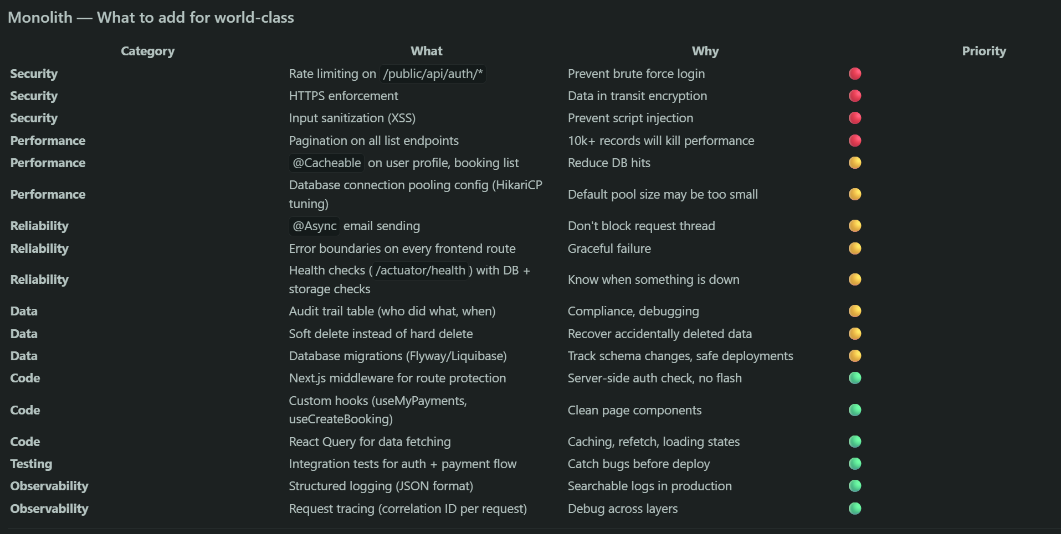

Microservice: -
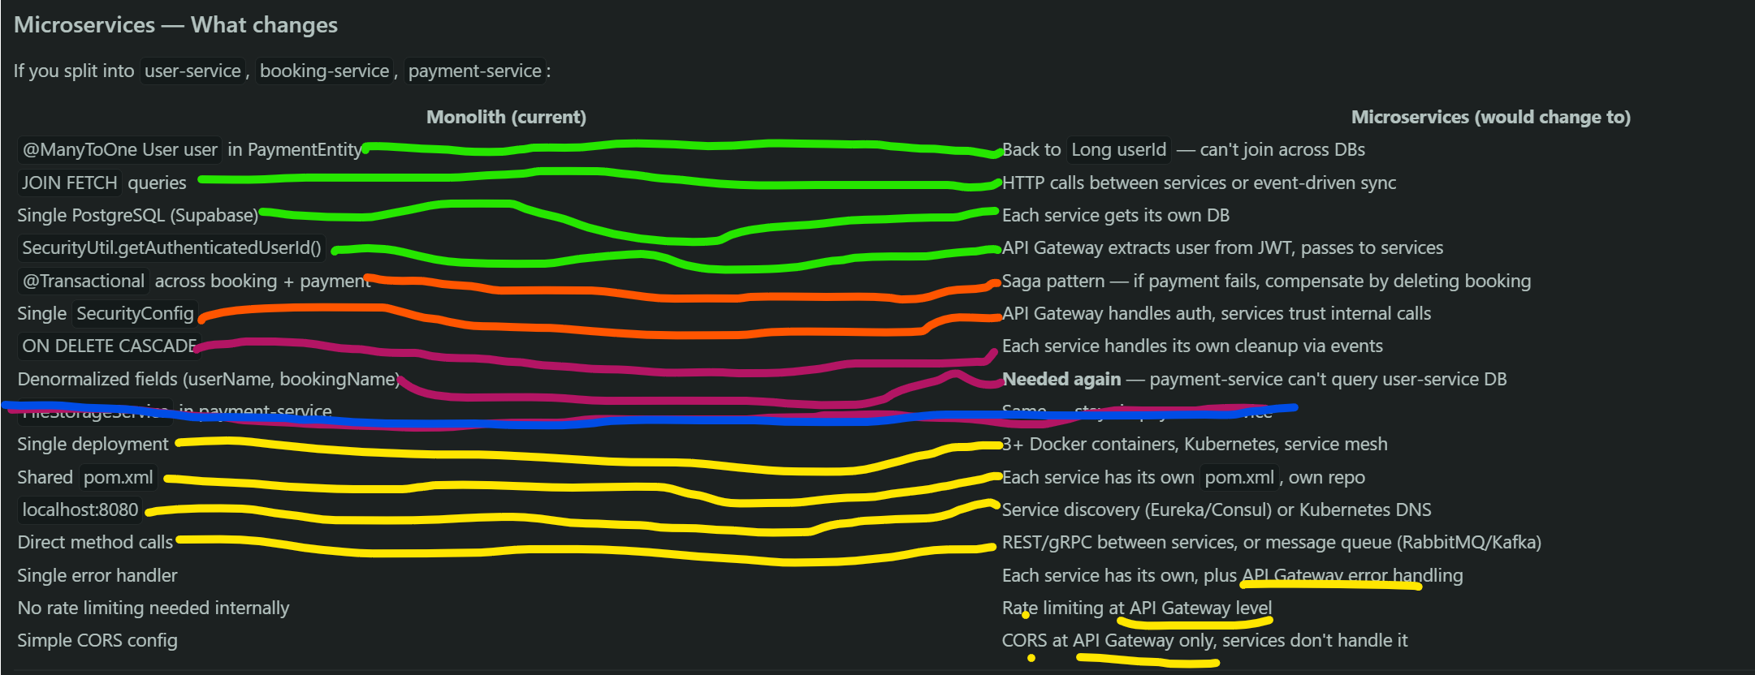

Beets, Golang version: -
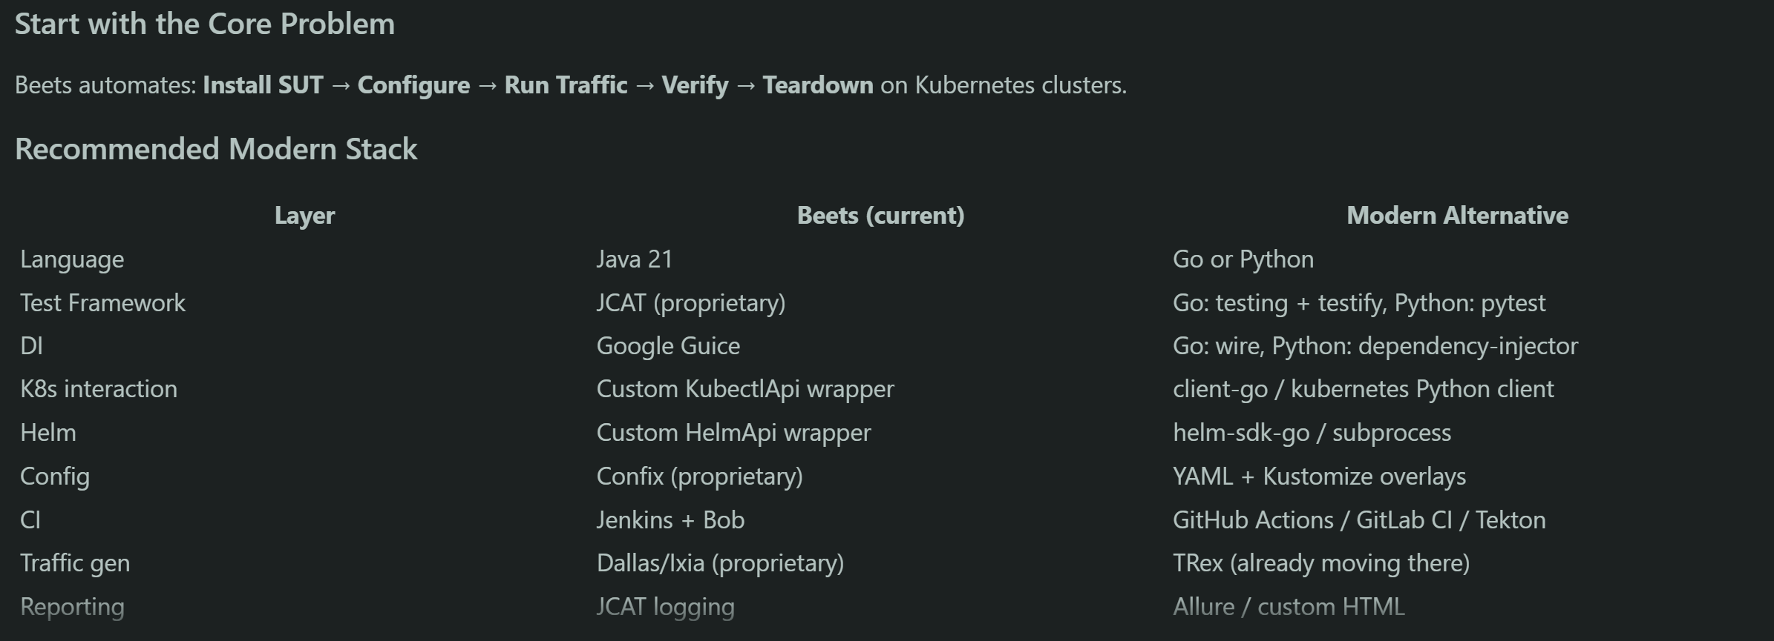
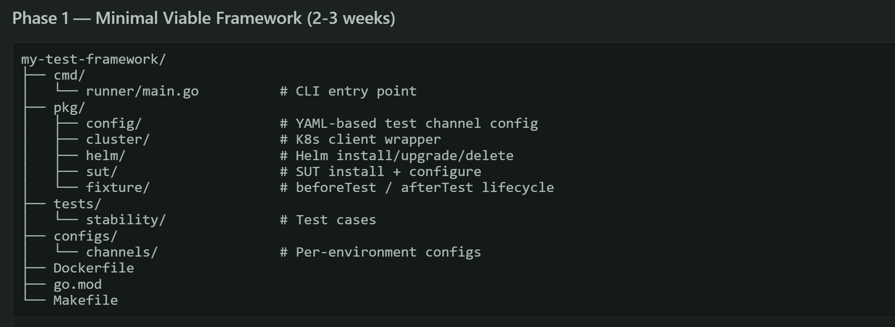
Goal: Install a Helm chart, wait for pods ready, run a basic health check, teardown.

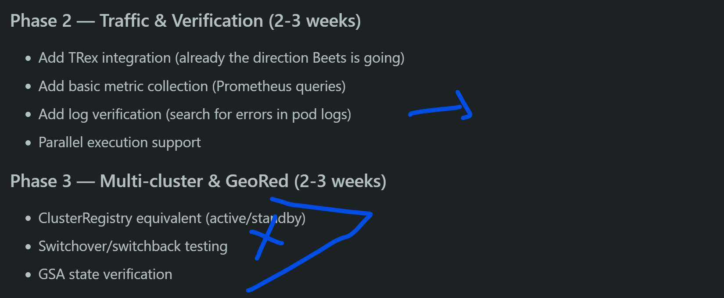
Traffic: -

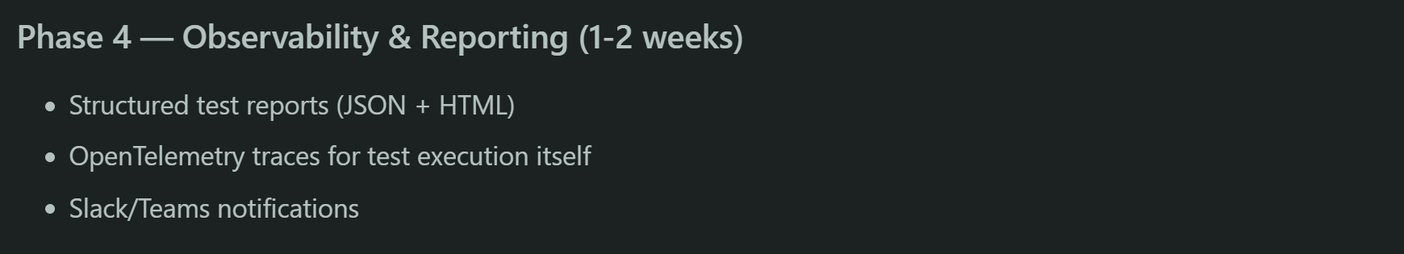
Observability: -

1, tools: -
Python3 clean_build.py
- set the Go environment correctly
- resolved dependencies (go mod tidy)
- compiled all packages (go build ./...)

We have solved:
- module system setup on a restricted cluster
- dependency resolution (including Kubernetes libs)
- reproducible builds via script
go build ./... only compiles and checks for errors — it doesn't produce a binary file. It's just a syntax/type check across all packages.
go build -o bin/beets ./cmd/runner :- To get an actual executable, you need to point to the main package.

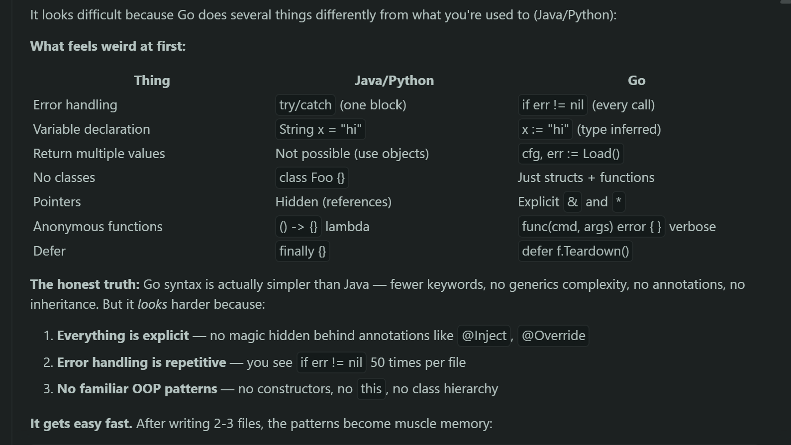

Tasks: -
Here's your 20 tasks:
- Config loader — parse YAML file into Go struct with cluster, SUT, traffic, and skip settings
- Config validation — check required fields exist, product is valid (pcg/pcc), at least one cluster defined
- K8s client — connect to cluster using kubeconfig, get pods, check pod status
- Namespace operations — create, delete, check if namespace exists before installing anything
- Helm install — run helm install with values file, wait for completion with timeout
- Helm health check — verify release is deployed, all pods from the release are running
- SUT install — combine helm install + wait for pods ready in the namespace
- SUT configure — apply configmaps and secrets to the namespace after install
- Fixture setup — wire config → cluster → helm → sut into a single Setup() call
- Fixture teardown — uninstall helm release, clean up namespace, always runs even on failure
- TRex config — generate TRex YAML config with NIC IDs and destination MAC
- TRex runner — download TRex, start traffic, stop traffic, get stats
- Traffic verification — check TRex stats for packet drops, expected throughput
- GeoRed state — connect to both clusters, run GSA state, parse active/standby
- GeoRed switchover — trigger switchover, wait for ready-to-switchover on new active
- GeoRed keys — install geored keys on each cluster with delay between installs
- Log scanner — fetch pod logs from namespace, search for ERROR/FATAL patterns
- Prometheus query — connect to Prometheus, query SUT metrics, verify thresholds
- Test report — collect test step results, durations, pass/fail, write JSON + summary
- First real test — CGNAT GeoRed stability: start traffic → switchover → verify no drops → switchback → verify clean logs

1, The fixture just orchestrates — it passes the config directory path, and each component loads only what it needs.
fixture is like a manager — it doesn't do the actual work, it just tells others what to do and in what order.
No fixture/. The orchestration logic lives in main.go → runTests().
pkg/runner/ — it runs the test lifecycle.
fixture sounds like a testing framework concept (JUnit/JCAT)
runner is clear — it runs the prepare → test → teardown flow

main.go calls runner.Run(ctx, configDir) — and the runner calls each component in order.
main.go — parses CLI args, creates the runner, calls it. Entry point only.
pkg/runner/ — the manager. Knows the ORDER (prepare → test → teardown). Calls each component but doesn't know HOW they work internally.
pkg/cluster/, pkg/sut/, pkg/traffic/, etc. — the workers. Each loads its own config, does its own job. Doesn't know about other components.
Runner = orchestrator. Packages = independent workers.

